

**Cloud Operations & Innovation (“CO+I”)**

**Pre-Market Feasibility Study of the Co-Location of**

**Trevi’s Waste (Residual) Heat Driven Forward Osmosis (FO)**

**Desalination Systems with Microsoft Data Centers Sites**

**CASE 1**

May 27th, 2025

Contents

Background 2

Waste Heat Utilization Scenario & Heat Pump Assumptions 3

Case 1: Brackish Water Datacenter Site Assumptions 7

DC Site location Criteria 8

Designing the FO Plant 9

Mass Balance and PFD 10

Levelized Cost of Water (LCOW) Analysis for FO and RO Scenarios 11

Results Summary: 12

Footprint and Uses 13

Potential Applications for FO Desalinated Water 14

Site Selection Criteria 14

Key Advantages of Coupling with Thermally Driven FO for Inland Desalination 16

## Background

Trevi Systems' thermally driven Forward Osmosis (FO) technology utilizes low-grade waste heat for desalination. Demonstrated across seven pilot trials, the technology has been shown to reduce both electrical energy requirements and the Levelized Cost of Water (LCOW) compared to traditional reverse osmosis (RO) systems—transforming an otherwise wasted resource (low-grade heat) into a valuable one (clean water).

Most of Trevi’s demonstrations have used seawater as the feed source and solar thermal energy as the heat input. However, deployment is limited by the need for co-located heat and water sources, especially due to the long-term storage limitations of solar thermal energy.

Data centers (DCs) present a compelling solution. They generate abundant waste heat—up to 1 GW—and are often located near impaired water sources that require desalination, as well as near population centers with growing water demands.

This report evaluates three deployment scenarios:

Case 1: Inland sites with low-salinity brackish groundwater

Case 2: Coastal sites using seawater

Case 3: Inland sites near oil and gas operations with high-salinity produced water

For each case, the report explores how location, feedwater salinity, and co-location with data centers using 30 °C waste heat influence the quantity and quality of desalinated water, as well as the resulting LCOW compared to conventional RO systems. High-level engineering schematics, including mass balances and plant footprint estimates, are provided. A simplified techno-economic analysis (TEA) is also performed using average monthly ambient temperatures rather than hourly data.

Waste Heat Utilization Scenario & Heat Pump Assumptions

This analysis considers a nominal 1 MW thermal cooling load from a data center, with waste heat rejected at either 30 °C or 45 °C and a return temperature fixed at 18 °C in a closed-loop cooling configuration, as shown in Figure 1. Trevi’s FO system operates at 85 °C, requiring a temperature lift of up to 50 °C (from 30 °C), or slightly less in the 45 °C case. Both are considered high-lift applications and require appropriately designed heat pumps.

Conventional DC cooling is typically achieved using chillers or evaporative systems. Trevi’s proposed approach involves coupling to existing infrastructure through a heat exchanger, rejecting the heat pump’s cooling output into the DC system. While this reduces chiller load and evaporative water losses, the analysis focuses on comparing the use of low-grade waste heat from the DC versus ambient air-source heat, using monthly average temperatures as a proxy.

In hot regions like the dry Southwest, high temperature lifts from ambient air are possible with relatively high coefficients of performance (COPs) during summer months. However, performance degrades sharply in colder months, strengthening the case for year-round access to stable, low-grade waste heat from data centers.

*Fig. 1 Trevi’s FO System Integrated into the DC cooling system with Heat Pump*

**Selection of Heat Pump:**

A DC heat pump’s refrigerant is selected to both meet greenhouse warming potential (GWP) mandates as well as its lift requirements (in our case either 55oC or 47.5oC). Common refrigerants meeting these goals are shown in Table 1 below. Of these, R-1234yf is suitable for many air-sourced applications with low GWP but it does not provide sufficiently high temperature for use by Trevi’s FO system. Refrigerants such as R-744 (trans critical CO2) offer low GWP as well as higher reject temperatures and offer a good blend of both temperature lift and zero GWP. Lift is defined as the average temperature difference between the Condenser temperature and the evaporator temperature. Generally, the higher the lift, the lower the efficiency of the heat pump, and there for the higher the operating cost (electricity usage) of the system. For the proposed DC inlet of 30C and outlet of 18C, the evaporator side average is 24C, while for the proposed FO plant the hot side condenser is 85C and outlet 73C, the average is 79C, for a lift of 79C-24C = 550C.

To select the optimum operating conditions for the heat pump we seek to minimize the lift to that absolutely necessary to run the FO system. This will provide for maximum efficiency, defined as its Coefficient of Performance (COP). COP can be readily calculated by dividing either the cooling heat (kW) by the electrical energy necessary to do so, or by the heat output by the electrical energy: COP= Qth/Win, where Qth is the thermal energy delivered and Win the electrical energy used. For DC heat pumps, where the heat is typically rejected to the atmosphere, the COP is then just the cooling heat divided by the electrical input. Inthis analysis, only the heating side COP is used for energy calculations, the COP from cooling is ignored. COP values of 2.5-5 are typical of warmer climates, but as most of the Southwest have low winter temperatures, COP’s can fall to below 2 in winter months.

The estimated COP for a number of popular refrigerants is shown in Table 1 below, with R-515B giving a good COP of 3.3 at a lift of 55oC in summer months.

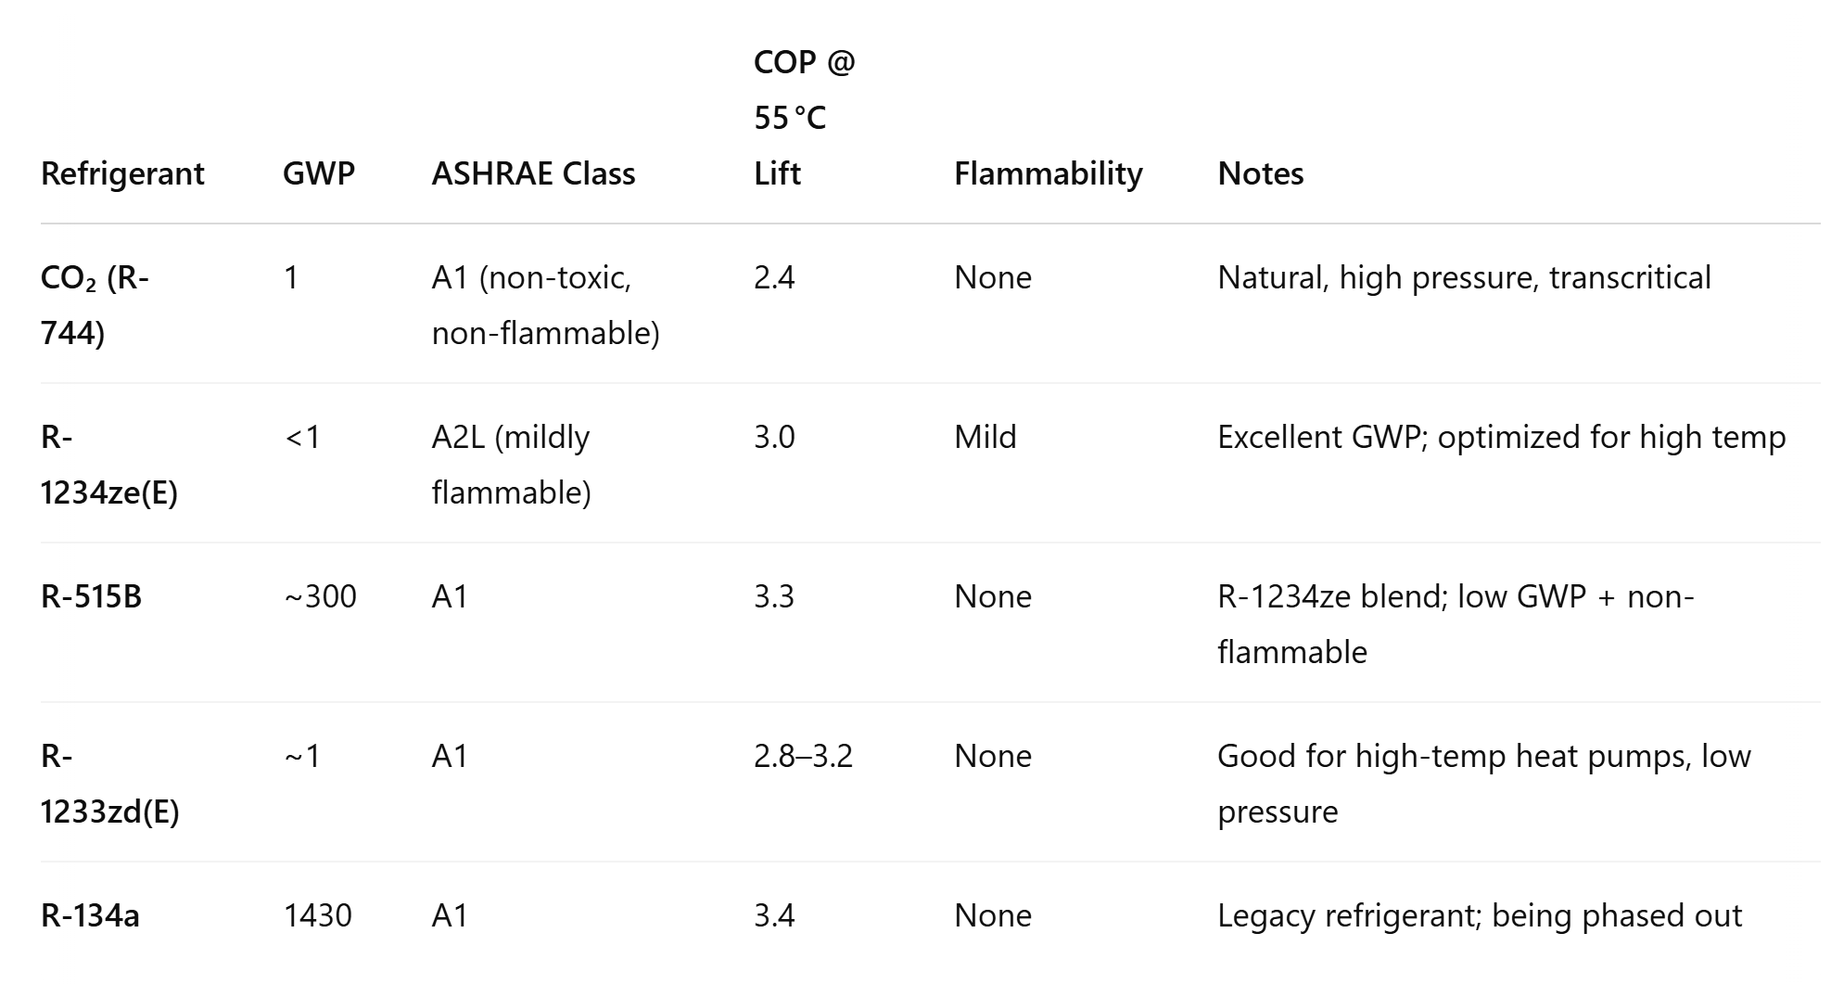

*Table 1. Refrigerant choices for DC Industrial heat pumps with 55C lift.*

Ammonia (R-717) offers the highest COP at 3.5 (but its toxicity requires special handling), with R-515B a close second. There are at least 3 thermodynamic cycles that can achieve high lifts, including cascade heat pumps, trans critical CO2 as well a number of newer, novel cycles such as rotational heat pumps using inert gas blends.

There are many heat pump manufacturers offering high lift systems as shown in table 2 below. It is important to note than even small COP differences (0.1 to 0.2) in heat pump efficiency (COP) translate into large savings over 20 years when large thermal loads are considered:

*Table 2 HTHP suppliers, (courtesy 14the IEA Heat Pump Conference, May 2023)*

The above list is by no means exhaustive, and the heat pump field sees new entrants on a regular basis, such as ECOP with its rotational heat pump using noble gases (<https://www.ecop.at/en/home-4/>) and Turboden (<https://www.turboden.com/>) with its large multi-MW heat pumps all capable of 100K lifts using R744.



From Table 2 above, heat pumps at the 1MW scale are expected to cost around $250/kWth, a 1MW cooling unit then costing around $500,000 in CAPEX. This assumption will be used as an input to the TEA and included as part of the FO CAPEX. The ECOP heat pump was used for this TEA based on their simulation of the demand shown in table 3 below:

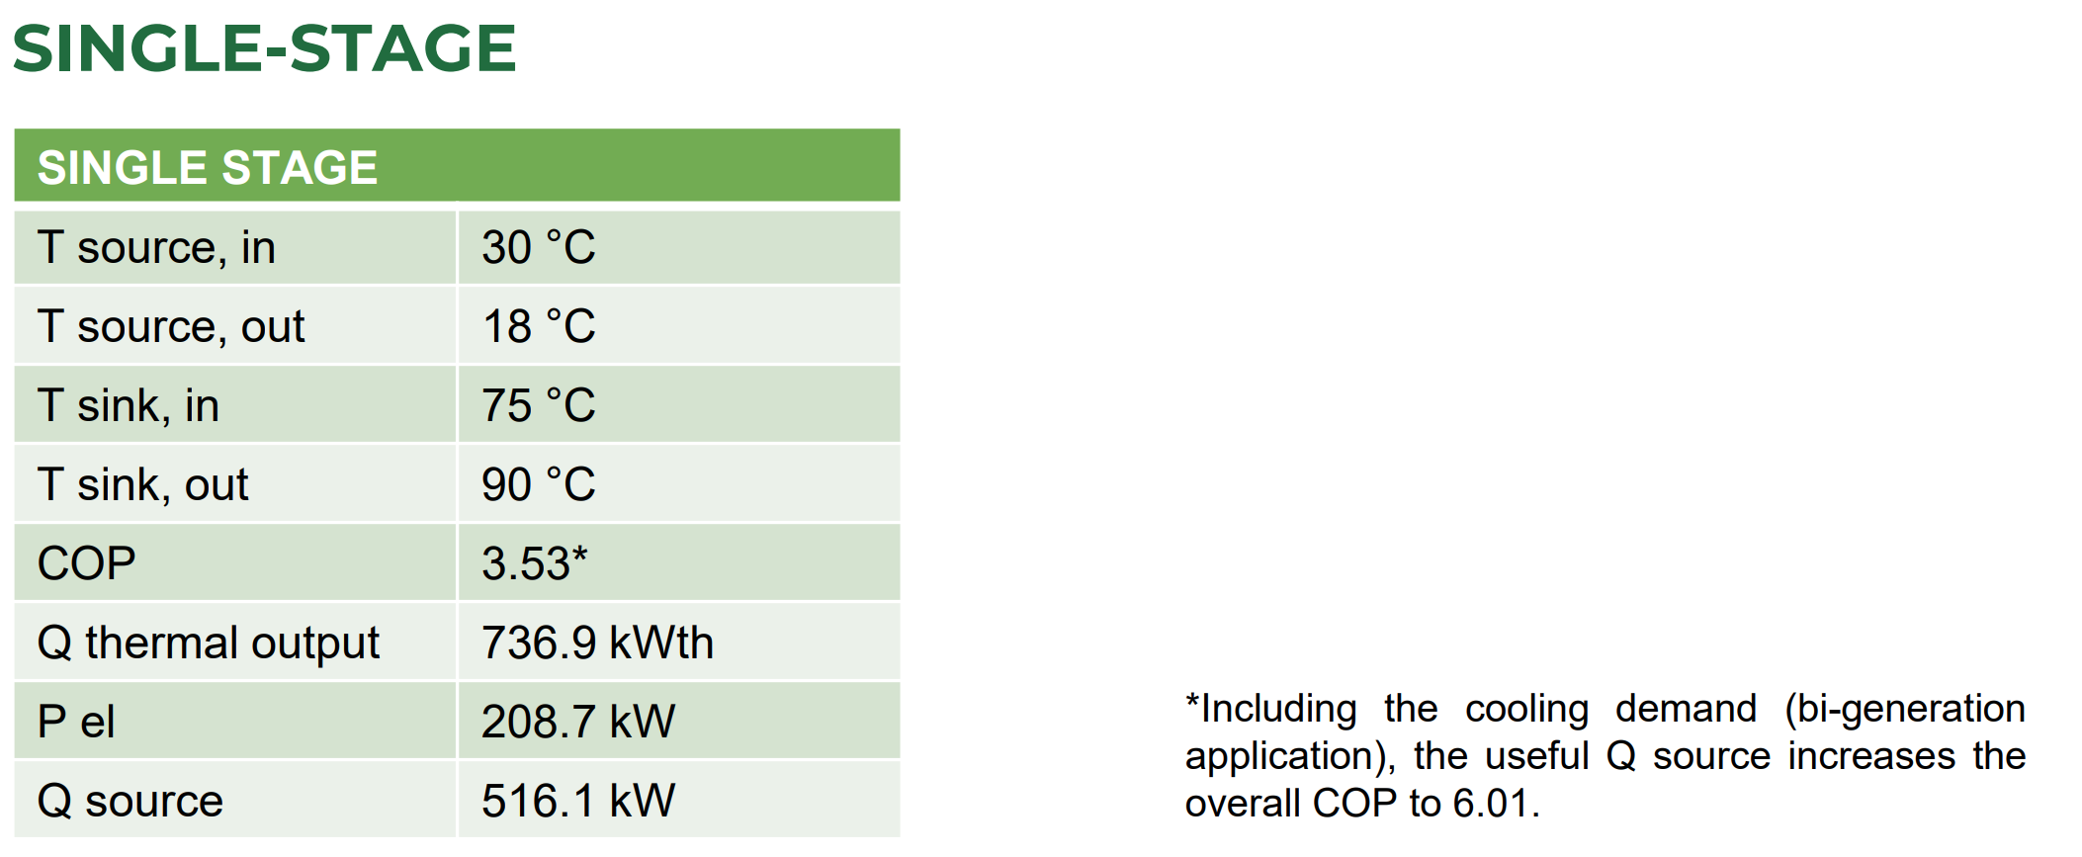



*Table 3. ECOP Heat Pump parameters (courtesy ECOP)*

From the simulation of its performance, we can see that the overall COP approaches 6.01, and the electrical input necessary for 500kW of cooling is 208.7kW. Two units would meet the cooling demand of 1MW, while providing 2*736kW of high temperature heat which will be sufficient to power a Trevi FO desalination plant.

## Case 1: Brackish Water Datacenter Site Assumptions

Source Water Criteria:

Typical salinities for brackish groundwater range from: 1,000 to 10,000 mg/L total dissolved solids (TDS). Below is a more detailed breakdown for the definition of the 3 water types analyzed in this TEA and their corresponding salinities:

Freshwater: < 1,000 mg/L TDS

Brackish water: 1,000 – 10,000 mg/L TDS

Saline water: 10,000 – 35,000 mg/L TDS (Case 2 : Seawater salinities)

Brine: > 35,000 mg/L TDS (Case 3: Oil and gas produced wastewater salinities)

Typical inland brackish groundwater salinities range from: 1,000 to 5,000 mg/L TDS and for agricultural inland basins or sedimentary aquifers, typical TDS ranges from 1,000–3,000 mg/L TDS. (*Source:USGS (2014) – "Brackish Groundwater in the United States":)*

For our Case 1, Trevi will assume an incoming salinity of 2000 mg/L TDS and a final brine concentration of 150,000 mg/L as due to the inland characteristics of this site, brine from desalination plants will have to be minimized due to disposal restrictions and the high cost of disposal and/or trucking. 1MW of cooling based on the energy requirement for Trevi’s thermal FO desalination plant is projected to produce 1000m3/day of desalted water for 2000 mg/L of TDS. As mentioned previously, a 53.5 – 47.5oC lift is used for the TEA, and we assume a COP of 45% of Carnot for ambient air sourced heat pumps and a COP of 53% for the water sourced DC heat pump (due to the better heat exchange possible with liquid cooling). This COP number for water cooled closely matches the projected ECOP COP in Table 3 and provides the rational for the slightly higher COP.

Trevi’s FO system can use its standard draw solution which is capable of achieving the osmotic pressure sufficient to achieve the required brine concentration. Thermal and electrical power will remain largely constant over this input salinity range as shown in Table 5 below. The Plant is designed to produce potable water, making it suitable for all applications (except unique industrial applications such as boiler feed makeup, semiconductor etc). These can be accommodated, the water for potable use is re-mineralized. Permeate TDS will be less than 300mg/l as shown in Table 5. Production rate will remain constant independent of input salinity over the input salinity range of 2-10k as it is only 10% of the discharge salinity, therefore output production rate will not vary as the system is relatively unaffected by input salinity over this range. Hardness (as for the RO system) will ultimately be the limiting factor for either FO or RO systems. Trevi has developed a high efficiency electrically driven softening process which may be used should this become an issue (feedwater dependent).

### DC Site location Criteria

As the proposed heat pump must output a cold stream of 18oC to the DC, long pipe runs are undesirable in warm climates as the return temperature will rise with distance, negatively impacting the DC performance. The heat pump must therefore be collocated with existing heat pumps at the datacenter cooling system. Volumetric flow rates can be calculated from the formula Q = m*Cp*ΔT, where in this case the cold side ΔT is 30-18 = 12oC, water is assumed as the working fluid with a Cp of 4.2kJ/Kg-s and Q is 1MW thermal (1000kJ/s). The mass flow rate for cooling is then m=19.8kg/s or a flow rate of approximately 314gpm. A standard 4” PVC line will incur less than 5psi pressure drop over a 500ft pipe length between the datacenter and the cooling system, making this pipe size and run length guidelines for locating the heat pump. The hot water run from the heat pump to the FO system, using a hot side ΔT of 12oC and similar pressure drop again places a practical distance of 500ft between the FO System and the DC cooling system. Other factors such as location of power, security (fencing, lighting) make the choice of location as close to the cooling system as practical to share facilities. This implies that the water fed to the FO system is the one variable where, for a 686m3/day system, the 126gpm flow can then be readily transported over 1mile with 10psi pressure drop in a standard 4” PVC pipe. The data center should therefore ideally be sited within 1 mile of a brackish water source, and the DC, heat pump and FO system located no more 500’ apart to minimize pipe diameter and pressure drop. This distance from the water source can be readily extended to approximately 20 miles if a standard 8” HDPE pipe (SDR-17) is used, making this a practical distance for deployment. These constraints are summarized in Table 4 below using either the Hazen-Williams or Darcy-Weisbach equations for 10psi or 20psi pressure drops:

|  |  |  |  |
| --- | --- | --- | --- |
| Pipe Diameter | DC to Heat Pump | Heat Pump to FO | FO to brackish source |
| 4” PVC | 500’ | 500’ | 1mile |
| 8” HDPE | 2mile | 2mile | 20mile |

*Table 4 Co-location Distances*

A recommendation based on pipe pressure drops as well as temperature losses would be to locate the Heat Pump and FO system within 500’ of the DC, and the impaired brackish water source within 20miles of the DC.

### Designing the FO Plant

Based on the parameters and assumptions described above for Case 1, and using Trevi’s 8 FO systems built to date, a 1000 m3/day FO desalination plant was designed with a CAPEX of $1,661,668 and annual OPEX of $115,590 for chemicals and consumables (excluding energy which is calculated separately).

Appendix 1 lists the components of the 1000 m³/day FO system CAPEX, along with their corresponding percentages of the total capital expenditure. From Appendix 1, FO membranes make up the majority of the FO costing and will also be the component that, as volume increases, matures quickest in its cost reduction path, allowing future FO systems to be 10-20% lower in cost than what is used in this TEA.

The OPEX for a 1000 m3/day brackish inland groundwater FO plant includes annual chemical replacement, draw solution replenishment and spare parts for pumps, membrane replacements etc over a projected 20-year plant life. Appendix 2 lists the components of the 1000 m³/day FO system OPEX, along with their corresponding percentages of the total operating expenditure.

A detailed PFD with mass balances was also developed. Please see the next page for a brief overview of it. A more detailed diagram can be found in the corresponding EXCEL sheet along with mass balances sent separately.

### Mass Balance and PFD

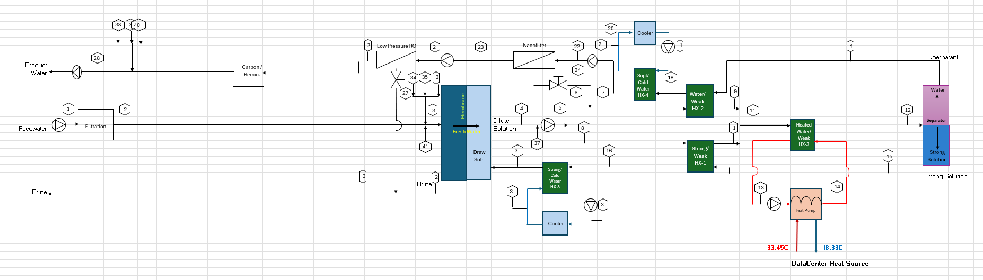PFD for 1000 m3/day Brackish FO plant

Mass Balances for 1000 m3/day Brackish FO plant

### Levelized Cost of Water (LCOW) Analysis for FO and RO Scenarios

This section presents the Levelized Cost of Water (LCOW) assumptions for four distinct system configurations, including FO with and without data center (DC) waste heat integration, and a comparative RO scenario. All systems are modeled to deliver 1000 m³/day of treated water which is what 1 MW of heat can achieve with a FO system for brackish ground water.

**Scenarios Evaluated:**

1. FO Only – Air-Cooled with Heat Pump:

A 1000 m³/day Forward Osmosis (FO) plant operating independently, without access to data center waste heat. The system uses air cooling and a heat pump to manage thermal requirements.

1. FO + DC Waste Heat (30°C Inlet & 18°C Outlet):

An FO plant utilizing 30°C waste heat water from a data center, feeding Trevi’s heat pump, and producing 18°C outlet water. The cooled water may potentially be recirculated to the data center for reuse in cooling.

1. FO + DC Waste Heat (45°C Inlet & 18°C Outlet ):

Similar to Scenario 2, but with higher-quality waste heat at 45°C. Trevi’s heat pump again cools the stream to 18°C, offering even greater potential for integration with DC cooling systems.

1. FO + DC Waste Heat (45°C Inlet & 33°C Outlet)

Similar to Scenario 2, but with higher-quality waste heat at 45°C. Trevi’s heat pump again cools the stream to 33°C.

1. Benchmark RO System:

A 1000 m³/day Reverse Osmosis (RO) plant powered entirely by electricity, designed to achieve the same water treatment performance as the FO systems for comparison purposes.

Table 5 summarizes the key techno-economic input variables used in the LCOW analysis for each scenario.

|  |  |
| --- | --- |
| Temperature lift of DC heat with FO | 53-55oC |
| COP for Ambient Air Cooling for FO plant (No waste heat from DCs for FO plant) | Dependent on monthly ambient surrounding temperature – See Appendix 3 |
| COP for Water Cooling for FO Plant (45% of Carnot & with waste heat from DCs for FO plant with 30 deg C in & 18 deg C out) | 3.5 |
| COP for Water Cooling for FO Plant (45% of Carnot & with waste heat from DCs for FO plant with 45 deg C in & 18 deg C out) | 4.05 |
| COP for Water Cooling for FO Plant (45% of Carnot & with waste heat from DCs for FO plant with 45 deg C in & 33 deg C out) | 4.8 |
| Electricity Cost | 0.08c/kWh |
| Heat Pump CAPEX | $500,000 |
| Brackish Water feed salinity | 2000mg/l |
| Brackish water brine discharge | 150,000mg/l |
| System recovery rate (FO and RO) | 98.7% |
| FO thermal Energy | 35kWh/m3 |
| FO Electrical Energy | 1.1kWh/m3 |
| RO Electrical Energy | 12.5kWh/m3 |
| FO or RO system Availability | 98% |
| FO or RO Permeate Water Quality | <300mg/l |

*Table 5 TEA Input variables*

Other assumptions and scenarios include:

1. The DCs supplies waste heat to the Trevi supplied heat pump which lifts it to the required 85oC for the FO plant draw solution separation.
2. Six city locations in the US which are known to have brackish ground water as a source are evaluated. These sites are:
   1. Phoenix, Arizona
   2. Alamogordo, New Mexico
   3. Albuquerque, New Mexico
   4. Midland, Texas
   5. El Paso, Texas
   6. Fresno, California

Various cities in the US have been chosen to evaluate if the average monthly temperatures have an impact on the economics for the LCOW of FO together with the waste heat from data centers

1. The CAPEX for the RO system used is that of an ultra-high pressure RO system or an osmotically assisted RO system to achieve the high brine salinity which is necessary for inland brackish water sites to minimize brine disposal.

### Results Summary:

Using Table 5 above, the various scenarios are calculated below for 5 different geographical locations and the results shown in Table 6 below. A demonstration of how the numbers for Fresno, CA was derived is shown in Appendix 4.



*Table 6. TEA Analysis for Inland Brackish desalination*

What is immediately evident is that a slightly higher heat source enables better numbers and a thermally driven FO system is capable of turning the waste heat into a positive benefit for the desalination plant, lowering the cost of water produced by an average of 18% when waste heat at 30oC is available and to over 26% when waste heat at 45oC is available.

In contrast, if an RO plant was built for inland brackish desalination, its impact would include an additional annual carbon generation component of ~1000MT over a similarly sized FO plant.

As FO technology matures and costs reduce due to economies of scale, municipal LCOW’s could approach $1.20/m3. The FO plant used above is designed for municipal drinking water applications, for agricultural applications, this LCOW could only be economical for high value crops such as berries and nuts. Many customers such as semiconductors would pay a significantly higher price, so that a datacenter FO desalination plant with industrial offtake agreements would make a lot of economical sense.

### Footprint and Uses

A 1,000m3/day FO system is approximately 15% larger than an equivalent size RO system, but the size discrepancy disappears as the plant size increases, as we will demonstrate in Case 4 of this report.

|  |  |  |
| --- | --- | --- |
| Datacenter Size – Thermal load | FO Plant Size  (m3/day) | FO Plant area - sq ft and (sq m) |
| 1MW | 1000 | 1600 (150m2) |

### Potential Applications for FO Desalinated Water

Brackish water is characterized by low feed salinity (typically 2-10k TDS) and high hardness. Trevi’s FO technology first electrochemically softens the water before desalinating it to achieve MLD. The feed water contents typically dictate the final usage of the water. For inland brackish sources, there are typically low levels of toxic organic chemicals, although in some instances nitrates, arsenic and mercury may be high. These are well rejected by the FO system, which is a 3-membrane process, so in principle, the permeate water may be used without restriction for both agriculture and human consumption. The limitation on potable water is the long regulatory certification hurdles, which can be site and county specific.

### Site Selection Criteria

The southwestern portion of the United States in well known to be experiencing a significant water shortage and includes New Mexico, Arizona, Texas and California as shown in the map fig 2. below.

A Data Center sited in this portion of the United States and capable of desalting 50-100,000m3/day would have a significant effect on its surrounding environs. The location should be chosen considering three key factors:

1. Access to low-cost, reliable power
2. Access to a significant brackish water reserve
3. Access to a high-speed fiber backbone for connectivity.

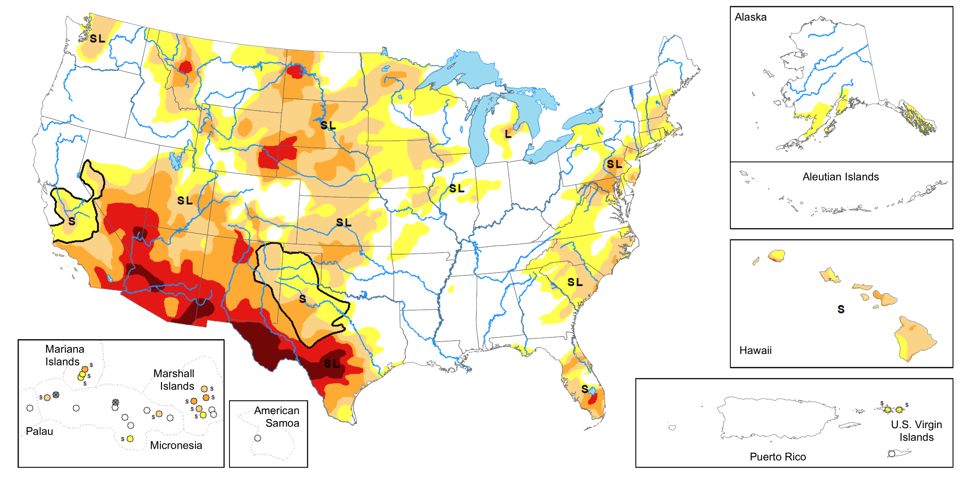

*Fig 2 Drought monitor (courtesy https://www.climate.gov/maps-data/dataset/weekly-drought-map)*

Fortunately, brackish water reserves are well mapped by several US state agencies as listed below for New Mexico, Arizona, California and Texas:

(<https://geoinfo.nmt.edu/resources/water/projects/bwa/home.html>,

<https://www.azwater.gov/sites/default/files/2024-08/Final-Report_Brackish-Groundwater_ADWR-1.pdf>,

<https://www.waterboards.ca.gov/water_issues/programs/recycled_water/docs/2024/brackish-GW-write-up.pdf>,

<https://www.twdb.texas.gov/publications/reports/numbered_reports/doc/r363/b2.pdf> ).

The US fiber backbone is also well mapped: ( <https://broadbandmap.fcc.gov/home>, <https://www.datacentermap.com/datacenters/>, <https://www.technologyreview.com/2015/09/15/166239/first-detailed-public-map-of-us-internet-backbone-could-make-it-stronger/> ).

Using simple GIS tools one can overly these two constraints to come up with a short list of potential sites. Several of these appear to meet the criteria listed above. Of these, Trevi believes the following would be good candidates:

#### New Mexico:

There are 17 large brackish groundwater aquifers in New Mexico, with the highest quality ones being the:

* [San Luis Basin](https://geoinfo.nmt.edu/resources/water/projects/bwa/SanLuis/home.html)
* [San Agustin Basin](https://geoinfo.nmt.edu/resources/water/projects/bwa/SanAgustin/home.html)
* [Española Basin](https://geoinfo.nmt.edu/resources/water/projects/bwa/espanola/home.html)
* [Mimbres Basin](https://geoinfo.nmt.edu/resources/water/projects/bwa/mimbres/home.html)
* [San Marcial & Engle Basins](https://geoinfo.nmt.edu/resources/water/projects/bwa/SanMarcial-Engle/home.html)
* [Albuquerque Basin](https://geoinfo.nmt.edu/resources/water/projects/bwa/abq/home.html)
* [High Plains Aquifer](https://geoinfo.nmt.edu/resources/water/projects/bwa/highplains/home.html)
* [Socorro & La Jencia Basins](https://geoinfo.nmt.edu/resources/water/projects/bwa/Socorro-LaJencia/home.html)
* [Mesilla Basin](https://geoinfo.nmt.edu/resources/water/projects/bwa/mesilla/home.html)
* [Estancia Basin](https://geoinfo.nmt.edu/resources/water/projects/bwa/estancia/home.html)

The City of Albuquerque lies in the Albuquerque brackish aquifer basin, and with its fiber and power connectivity well established, provides an ideal location for a datacenter. Affordable land and proven brackish well access would be important factors. An alternative site is the Los Lunas area, which lies just to the south of Albuquerque and can draw water from the Socorro and La Jencia Basins.

#### Arizona:

Brackish groundwater reserves are estimated at between 500-700million acre-ft (863billion m3) at a depth of 1200-1500ft. Large aquifers include Gila Bend, Ranegras Plain, West Salt River Valley, and the Little Colorado River Plateau. Fiber connectivity tends to favor the area just to the south of metropolitan Phoenix, in the Chandler area. This is in the Gila Bend aquifer vicinity where the water is predominantly sodium chloride in nature and therefore the softening can potentially be avoided. Site selection should focus on affordable land parcels within 20miles of the Gila Bend aquifer.

#### California:

There are a number of current, and future (planned) desalination sites listed in the California report, two stand out as being suitable, one to the north of Los Angeles in the Oxnard area and the other to the north of San Diego in the Carlsbad area. Large brackish groundwater reserves are detailed in these areas and the availability of fiber and power infrastructure is good.

#### Texas:

West Texas has abundant land, large sources of renewable energy and substantial underground brackish water reserves (in the west tx area alone, there is over 370 billion acre-ft). Areas around Odessa and Sweetwater would make excellent choices, with either brackish water or produced water sources available for desalting. El Paso with its high water prices and Midland Texas with its produced water sources are also good choices. The report above details excellent brackish reserves in Texas and long cost land with abundant power make Texas a good choice for datacenter hosting.

In summary, 5 sites representative of the factors necessary for Data center co-location were selected in these states (1) Phoenix, AZ, (2) Alamogordo, Nm, (3) Albuquerque Nm, (4) Midland Tx and (5) El Paso Tx. These sites were simulated in the TEA analysis, Table 6 above.

### Key Advantages of Coupling with Thermally Driven FO for Inland Desalination

1) Waste Heat Valorization

A major challenge in closed-loop datacenter cooling is dealing with low-to-medium grade waste heat (typically 30–45 °C). Trevi’s FO system, using a thermally regenerable draw solute, is well-suited to operate at this temperature range and has a thermal energy demand of 35kWh/m3,thus a 1.4MW heat source from the heat pump (table 3) will be able to desalinate 1000kW*24hrs/35kWh/m3 = 1000m3/day. By connecting the heat pump's high-grade thermal output to the FO thermal regeneration unit, recovery of this valuable heat that would otherwise be dissipated inefficiently into the air, the COP of the heat pump increases from 3.5 to 6, if both the cooling and heating component is realized, resulting is a a significant energy saving to the data center. The desalination process scales linearly with size, so that a 100MW DC heat load then represents an opportunity to desalinate 100,000m3/day and a 1GW load up to 1,000,000m3/day. This size of water plant is sufficient for a city of 3,000,000 people.

2) Freshwater Production in Water-Scarce Areas

Inland datacenters often suffer from limited water availability, which impacts both cooling system performance and onsite operations. An FO system enables the facility to produce freshwater from impaired sources (e.g., brackish groundwater, municipal wastewater, or industrial effluents) using its own waste heat. This provides a sustainable, onsite water source, reducing dependency on local supply networks and enhancing water resilience—critical in arid or drought-prone regions. Site selection, location of the heat pump and FO plant will be further developed below.

3) Synergistic Temperature Matching

Heat pumps typically output at temperatures too low for industrial steam-based reuse but ideal for FO regeneration (75–90 °C). This makes FO systems a thermodynamically efficient match. Unlike membrane distillation or reverse osmosis (which require higher temperatures or high-pressure membranes), FO's lower driving pressure reduces membrane fouling and energy intensity, while the thermal regeneration step aligns naturally with the cooling system output.

4) Energy Consumption and Brine Concentration

By internally recycling thermal energy, the combined system reduces the electricity demand per liter of water produced and lowers total energy consumption. This is especially beneficial for grid-constrained datacenters or those running on renewables where electricity is at a premium. It can also reduce the load on dry coolers or air-cooled condensers, improving overall heat rejection efficiency. Trevi’s FO system has an electrical demand in inland applications of 1.1kWh/m3 up to 200,00mg/l salinity levels, whereas RO systems will operate at closer to 12.5kWh/m3 at these salinities. The inland brackish water TEA analysis is assumed to start at a feed salinity of 2000mg/l, but the required concentration to avoid toxic brine discharge issues is assumed to be 200,000mg/l, for an overall concentration of 98.7%.

5) Environmental and Regulatory Benefits

Using waste heat for water treatment can improve the environmental profile of the datacenter, qualifying it for sustainability certifications (e.g., LEED, Green Grid) and helping meet regulatory targets on water usage, wastewater discharge, or energy consumption. In regions with water reuse incentives (think water scarce inland areas), this integration could also offer economic returns. In addition, the 1000MT of avoided CO2 emissions over a traditional RO plant are also significant factors to consider.

Appendix 1: Breakdown of 1000 m³/day FO CAPEX Components

Appendix 2: Breakdown of 1000 m³/day FO System Operating Expenditure (OPEX)



Appendix 3: Mean Monthly Ambient Air Temperatures for 6 cities and the Corresponding Air COP





Appendix 4: Sample of LCOW Calculations for Fresno, CA





